Computer Vision and Scene Analysis

Final Project Report

**Ball Tracking**

**Using Hough Transform and Optical Flow**

Submitted By:

Mayank Lamba(ml5711)

Vivek Bharti(vb1275)

Anshul Sharma(as10950)

**Abstract:**

A lot of applications today require the use of object tracking in real time. For instance, ball tracking in baseball, tennis, soccer matches. Some applications can also be found in the gaming industry where developers require implementation of ball tracking in a projected space.

Building on the lines of that, our project is the realization of an environment in which a user is required to maneuver a ball and our system will track that ball using an outline with the same color as the ball. We will implement this using optical flow. We will require various concepts that we have learned in the class to implement this project, including optical flow, and some other basic functions for implementing the larger concepts. We are using HSV color space and using these color boundaries we will detect the green ball.

**Motivation:**

Our motivation for this project is to track the movement of a ball which can be used in various sports like Baseball, Basketball, soccer, volleyball etc. using different computer vision techniques that we learned in our class. We have used Hough Transform and Optical Flow Detection to perform the task.

**Introduction:**

We wish to implement multiple methodologies to detect a ball. At the offset, we will use edge detection in successive image frames of the video to find the edges of the ball, and then apply hough transform for circles to it as was discussed in the lectures. The primary source of data that we will be using is a video of a person maneuvering the ball, which we will be shooting ourselves. We will endeavour to make an efficient implementation so that the tracking can be done within the constraints of normal human movement. We expect our implementation to not only capture, but also track the movements of a ball within a frame in which the video will be shot.

Then we wish to implement the same using Optical flow. We will try to use the Lucas Kanade algorithm to implement the flow, and plot the vector flow using line plotting by comparing the successive frames that will be processed to calculate the flow.

The project delves into the major concepts taught in the class and will help us understand those concepts in a more practical environment.

**Approach:**

**1.** **Colored Ball Detection using Hough Transform for circles:**

In Hough transform for circles, there are three parameters in the Hough space – a0, b0, and r(for radius). Therefore the hough space exist in 3d.

The approach used for colored ball detection using Hough transform:

1. Specify the range of HSV color for color type(E.g. Green).
2. Convert Image to HSV to mask according to color range.
3. Mask the image to display objects in frame of same color.
4. Convert the Image RGB and then to Grayscale.
5. Smoothen the Image using 5x5 filter.
6. Create Edge Map and Orientation Map for the image
7. Threshold the edge map.
8. Traverse each pixel(a,b) in edge_map
   1. Get orientation corresponding to pixel from orientation_map
   2. If the pixel(a,b) is an edge, run for min radius -> max radius
      1. x = b - r cos(theta*PI/180)
      2. y = a - r sin(theta*PI/180)
      3. HoughSpace[rad,y,x] +=1

9. Non Maxima suppression of Hough space.

10. Get indexes of maximas in Hough space.

11. Plot the circles onto the original image.

We have implemented the hough circle detection to detect green balls by masking the image to find certain range of colors in the window. We have implement the code in the stored video and the real time window as well. What we observed is that hough transform can be very slow to display the result in the real time and for video. To overcome this challenge, we have resized the image grid so the computation is faster.

**Data-Used:**

We are using the real-time video and a stored video to display and test our results. The image used is test2.mp4, which is low format video file so that we can have good results with hough transform for circle detection.

**Challenges Faced:**

1. One of the challenges we faced using hough transform with real-time video and stored video is the computation time and speed. The results were showing, but the video playback time reduced, as running the hough transform on each frame is time consuming.
2. The initial code ended up detecting circles other than the ball as well, making it inconsistent with the problem statement.

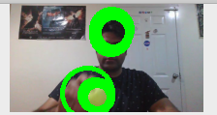

Fig 1. Multiple circles detected

**Solutions To the Above Problem:**

1. Reduced the grid size to decrease the computational time of hough transform on each frame.
2. Converting the color space of the image into HSV to detect color (in this case green) using a range of values that specified the green color. Then applying a mask to the image frame to specifically detect the green ball.
3. Implementation of Itertools and numba to speed up the loops and function calls in python code.

**Observed Results:**

Earlier, all the circular object in the image frame were being detected. By applying mask to the image frame, we were able to detect only those circular object which were green in color. This shows the difference between the result after applying the color mask. We also improved the efficiency of the code by decreasing the grid size. But still there was delay in running the videos as the hough transform would take a lot of processing to detect the image. We would need a high performance hardware to run the code without any delay. This gives us the motivation to run ball detection with optical flow, which gives us much better results.

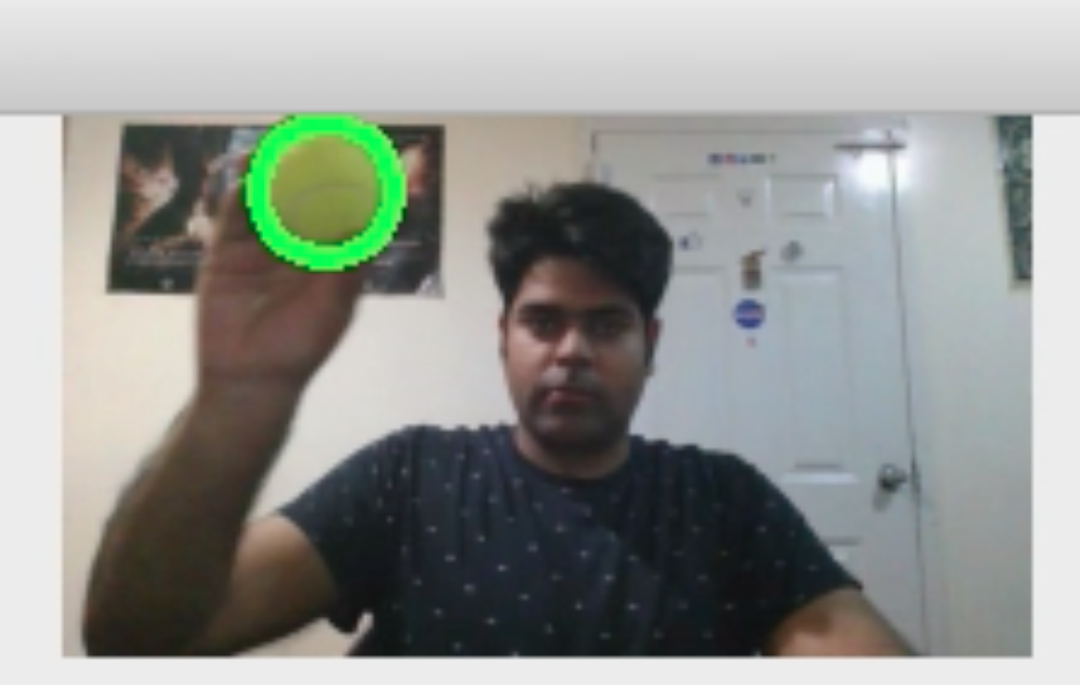

Fig 2. Hough Transform for Ball Detection

**Testing/ Validation:**

We have also included some tests regarding our implementation. We have taken two videos at a time, one with green color and one with orange color. The hough transform for green ball detection only detects green ball as the mask is set only for the green color range. Also, it is only highlighting the correct location of the green ball without any unnecessary highlights. The implementation of non maxima suppression and getting only peaks from the hough space is responsible for such accurate results.

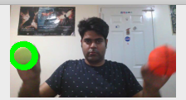

**2. Colored Ball Detection Using Optical Flow:**

**Approach:**

We have tried to implement the Lucas Kanade algorithm for optical flow. The algorithm basically works on the grayscale images of the successive frames and calculates the flow vectors and speed in *x* and *y*.

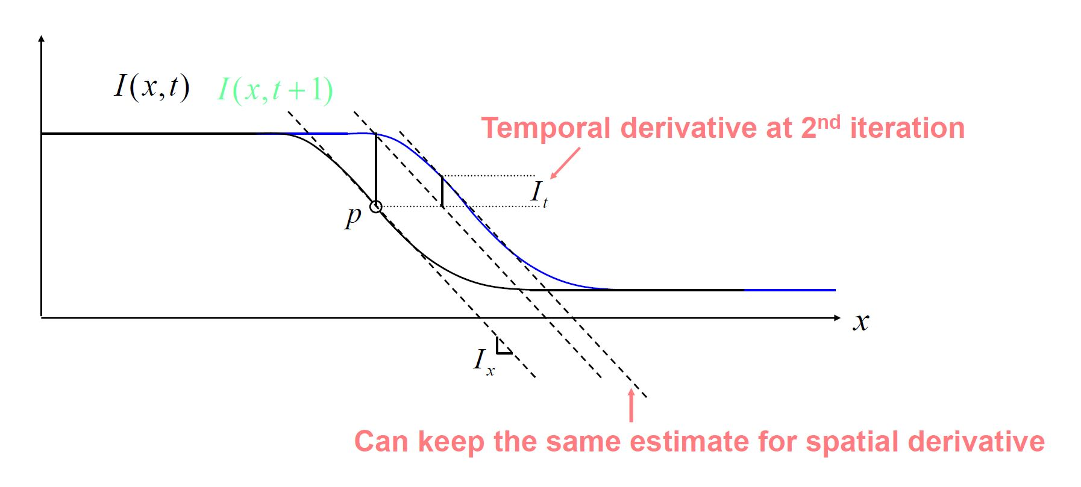

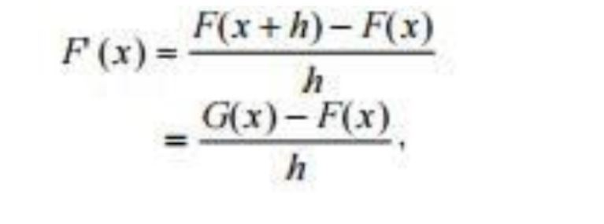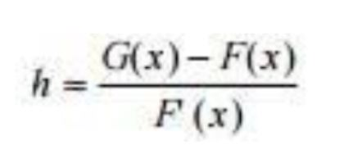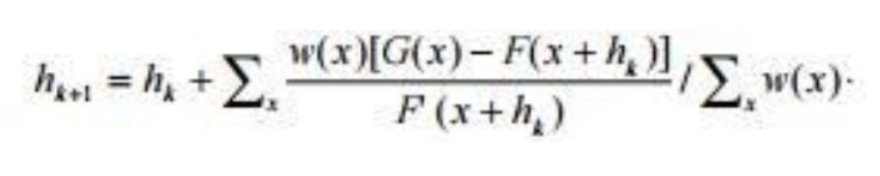

The approach used for colored ball detection using Optical Flow:

1. Capture the video frame using opencv
2. Initialize global variables to be used in the code
3. Resize the image to VGA (640x480) frame size
4. Convert the color space to HSV
5. Create a mask for the range of the color of the ball to be detected (here, green)
6. Apply the mask to the HSV image
7. Convert to grayscale (for that first convert from HSV to BGR and then BGR to Gray)
8. Apply Lucas Kanade to get the flow matrix
9. Plot the vector lines using the vector flows of current and previous image frames by traversing the frame
10. Either wait for the video to finish or use keyboard interrupt to exit

**Data-used:**

We are using the real-time video and a stored video to display and test our results. The image used is test2.mp4, which is low format video file so that we can have good results with Optical Flow Detection.

**Challenges Faced:**

1. Computational constraints: The image frames were too large and hence computation heavy resulting in an overall implementation that wasn’t satisfactory.
2. Basic optical flow resulted in detecting movement of objects other than the ball as well.

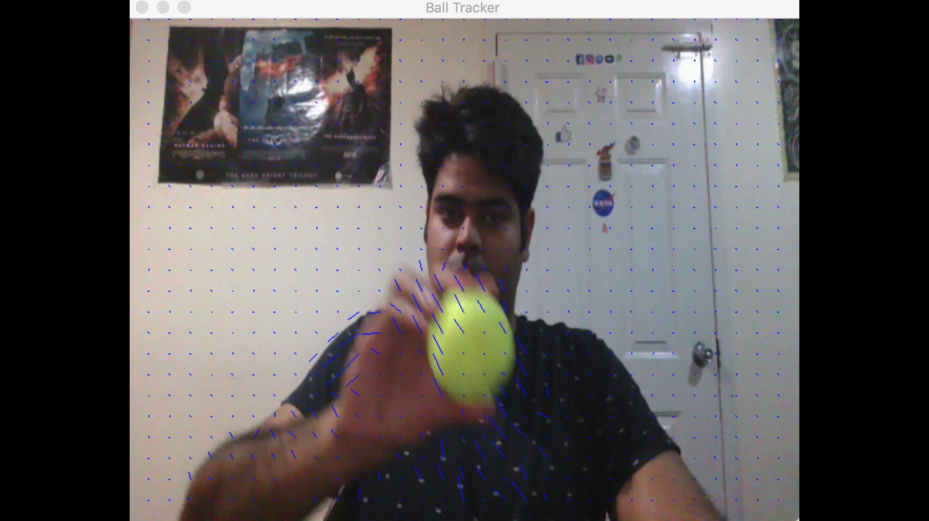 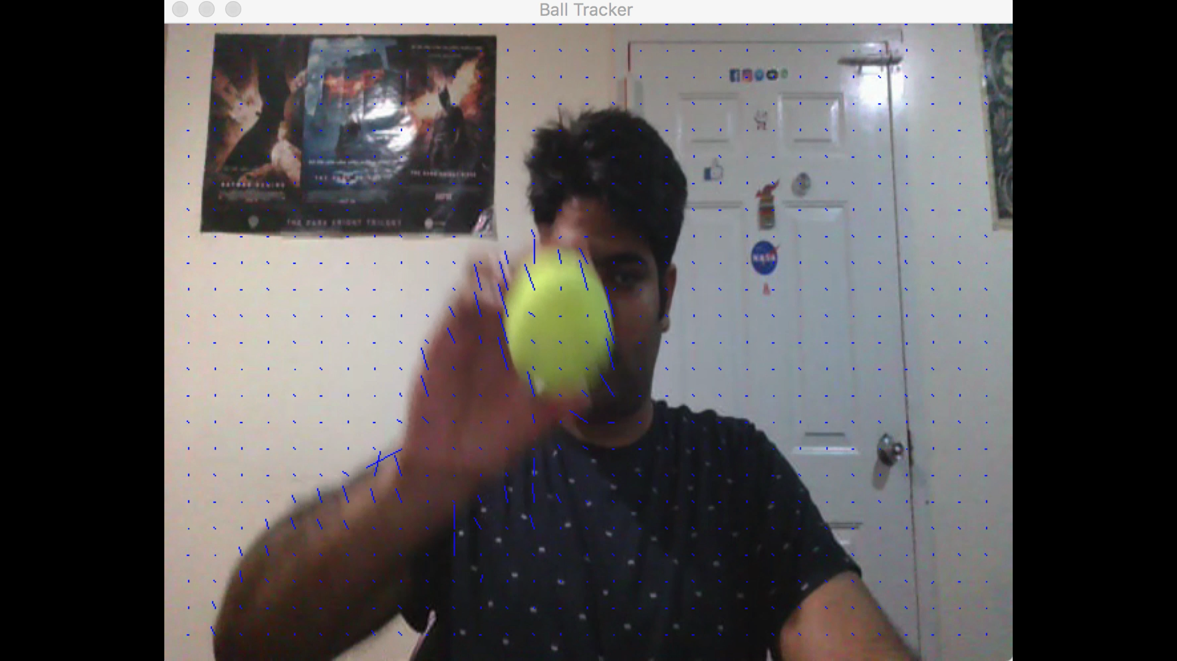

Fig 3. Unwanted motion detected

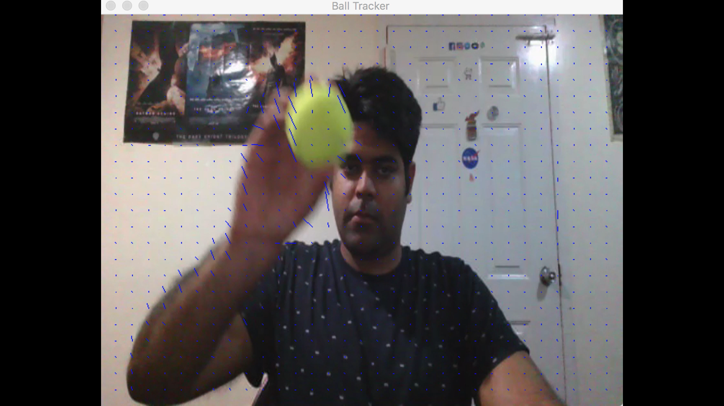

Fig 3. (continued)

**Solution To the Above Problems:**

1. Resizing of the image frame was done to the VGA resolution of (640, 480) in order to reduce the amount of computation and essentially facilitate the working of the code for a video which has multiple successive frames.
2. Converting the color space of the image into HSV to detect color (in this case green) using a range of values that specified the green color. Then applying a mask to the image frame to specifically detect the green ball. This helped in detecting the motion of just the ball and not anything else.

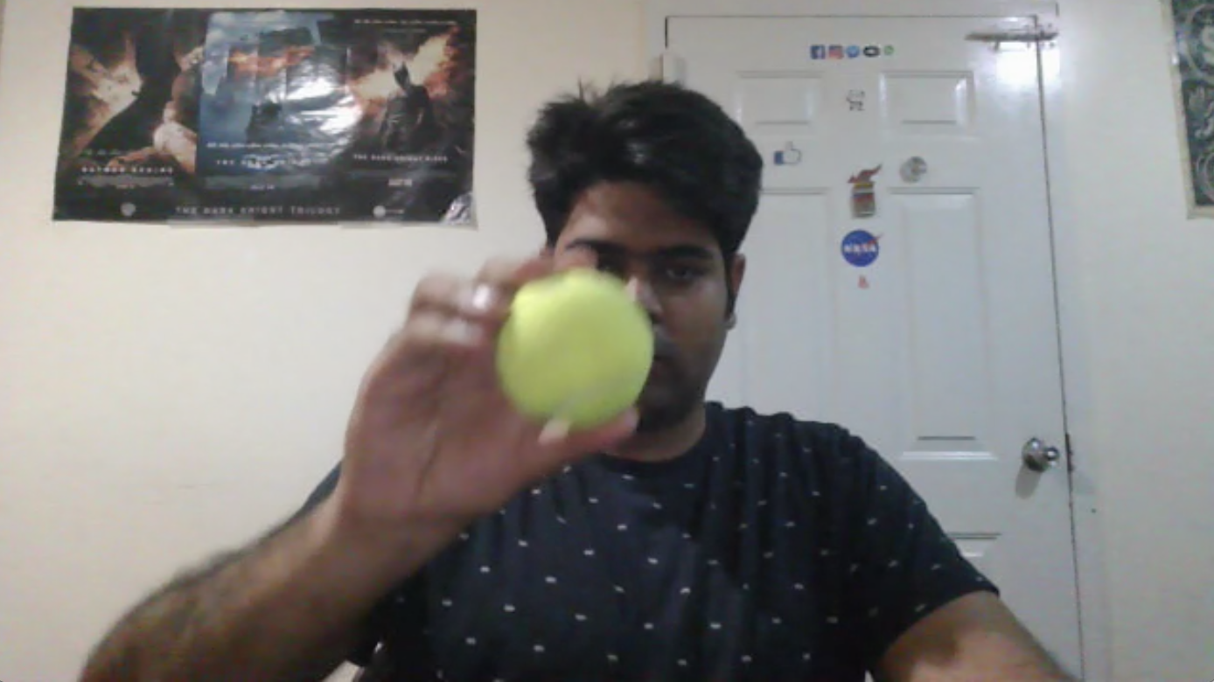

Fig 4. Normal BGR frame

**Observed Results:**

As can be seen in the following images, the color space was converted to HSV and then converted into gray to provide a single channel image on which processing could be efficiently done.

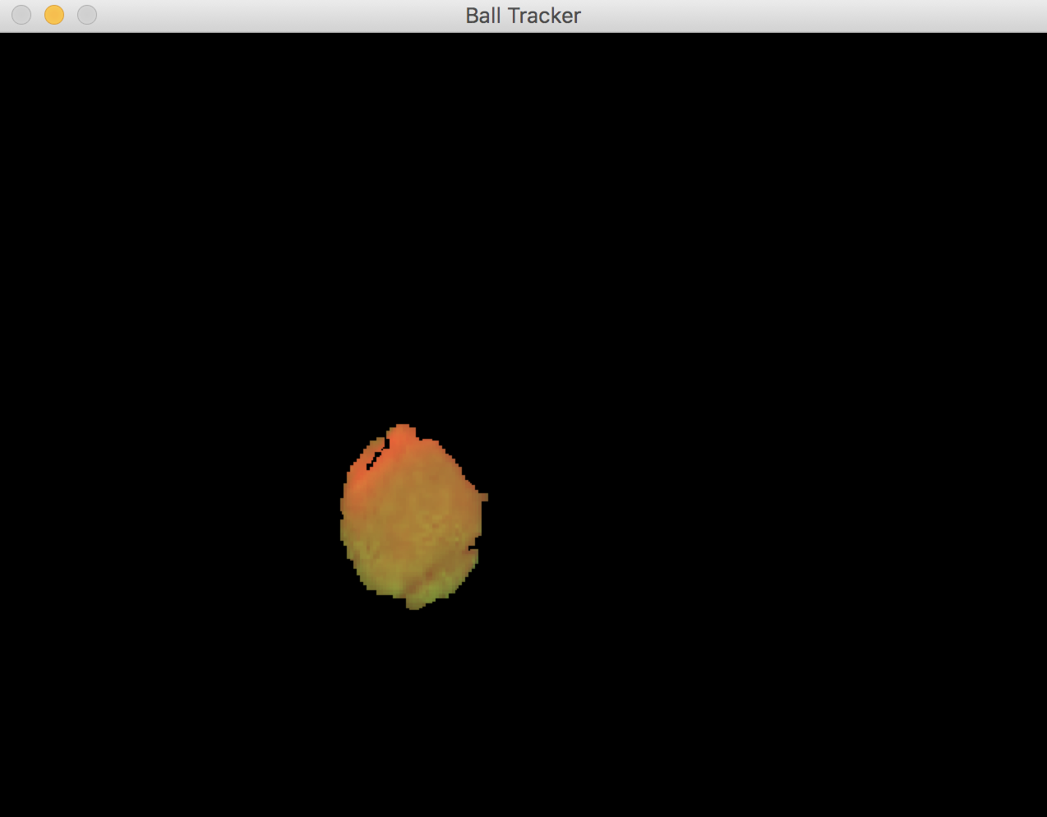 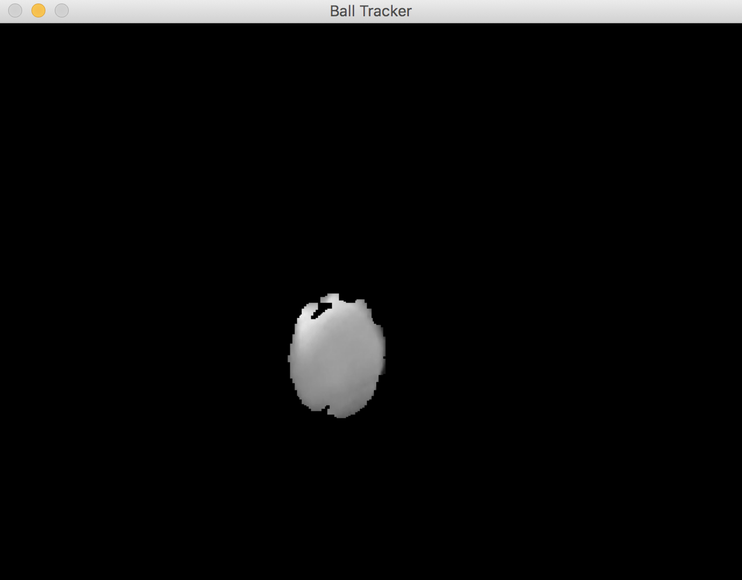

Fig 5. HSV color space (on left), Grayscale frame (on right)

The following images show the flow vectors depicting the direction the ball is going in. It is important to note that now, only the ball’s flow (that is green) is detected.

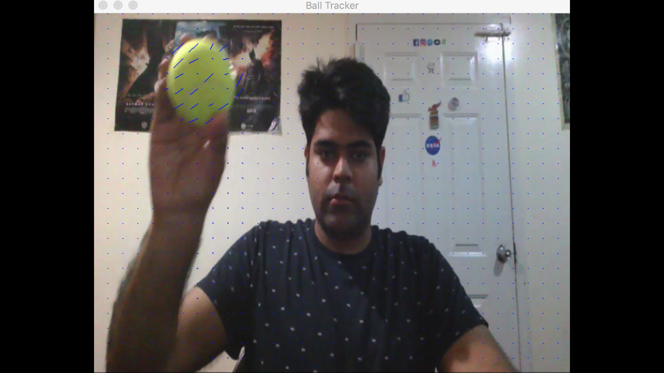 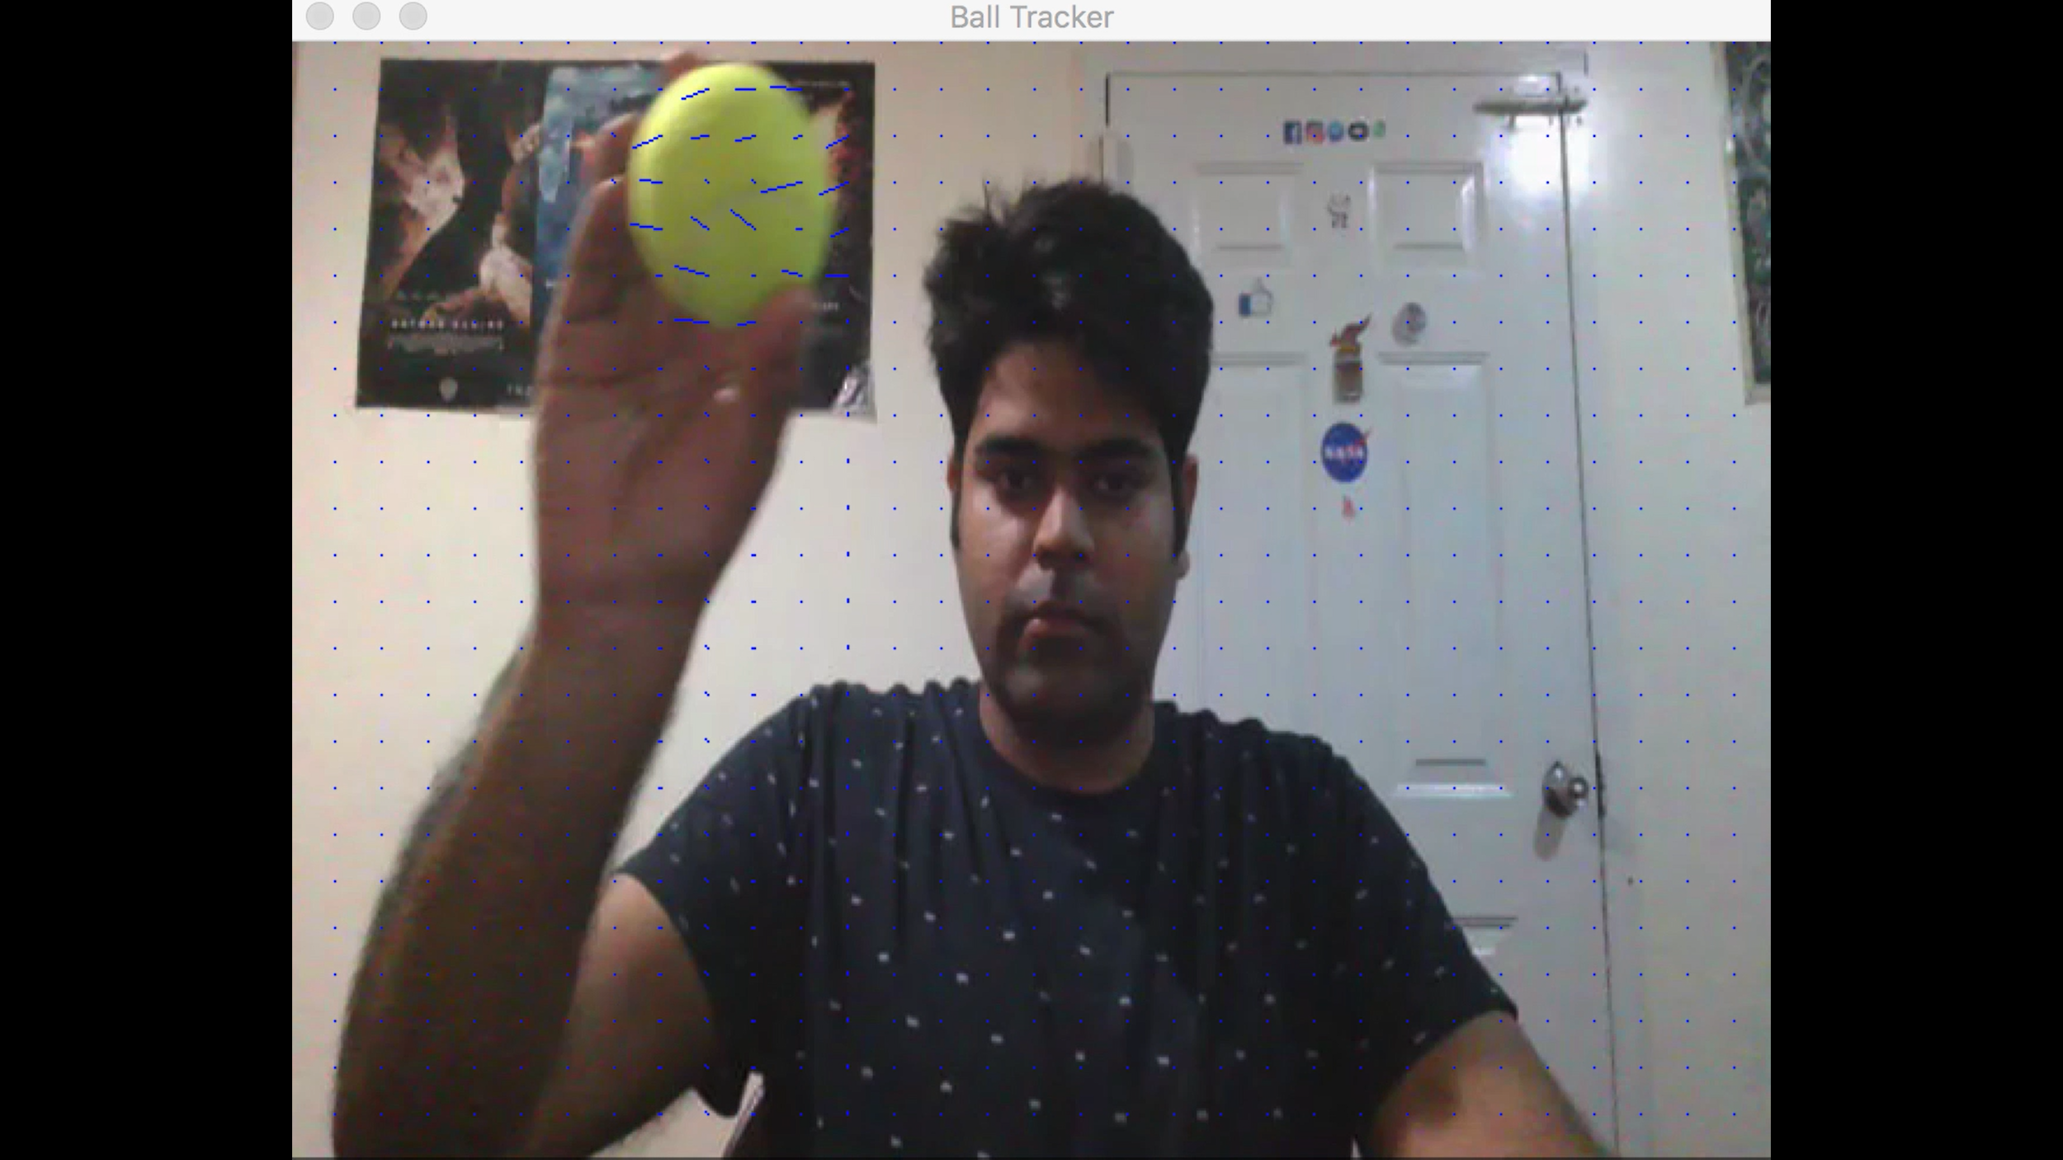

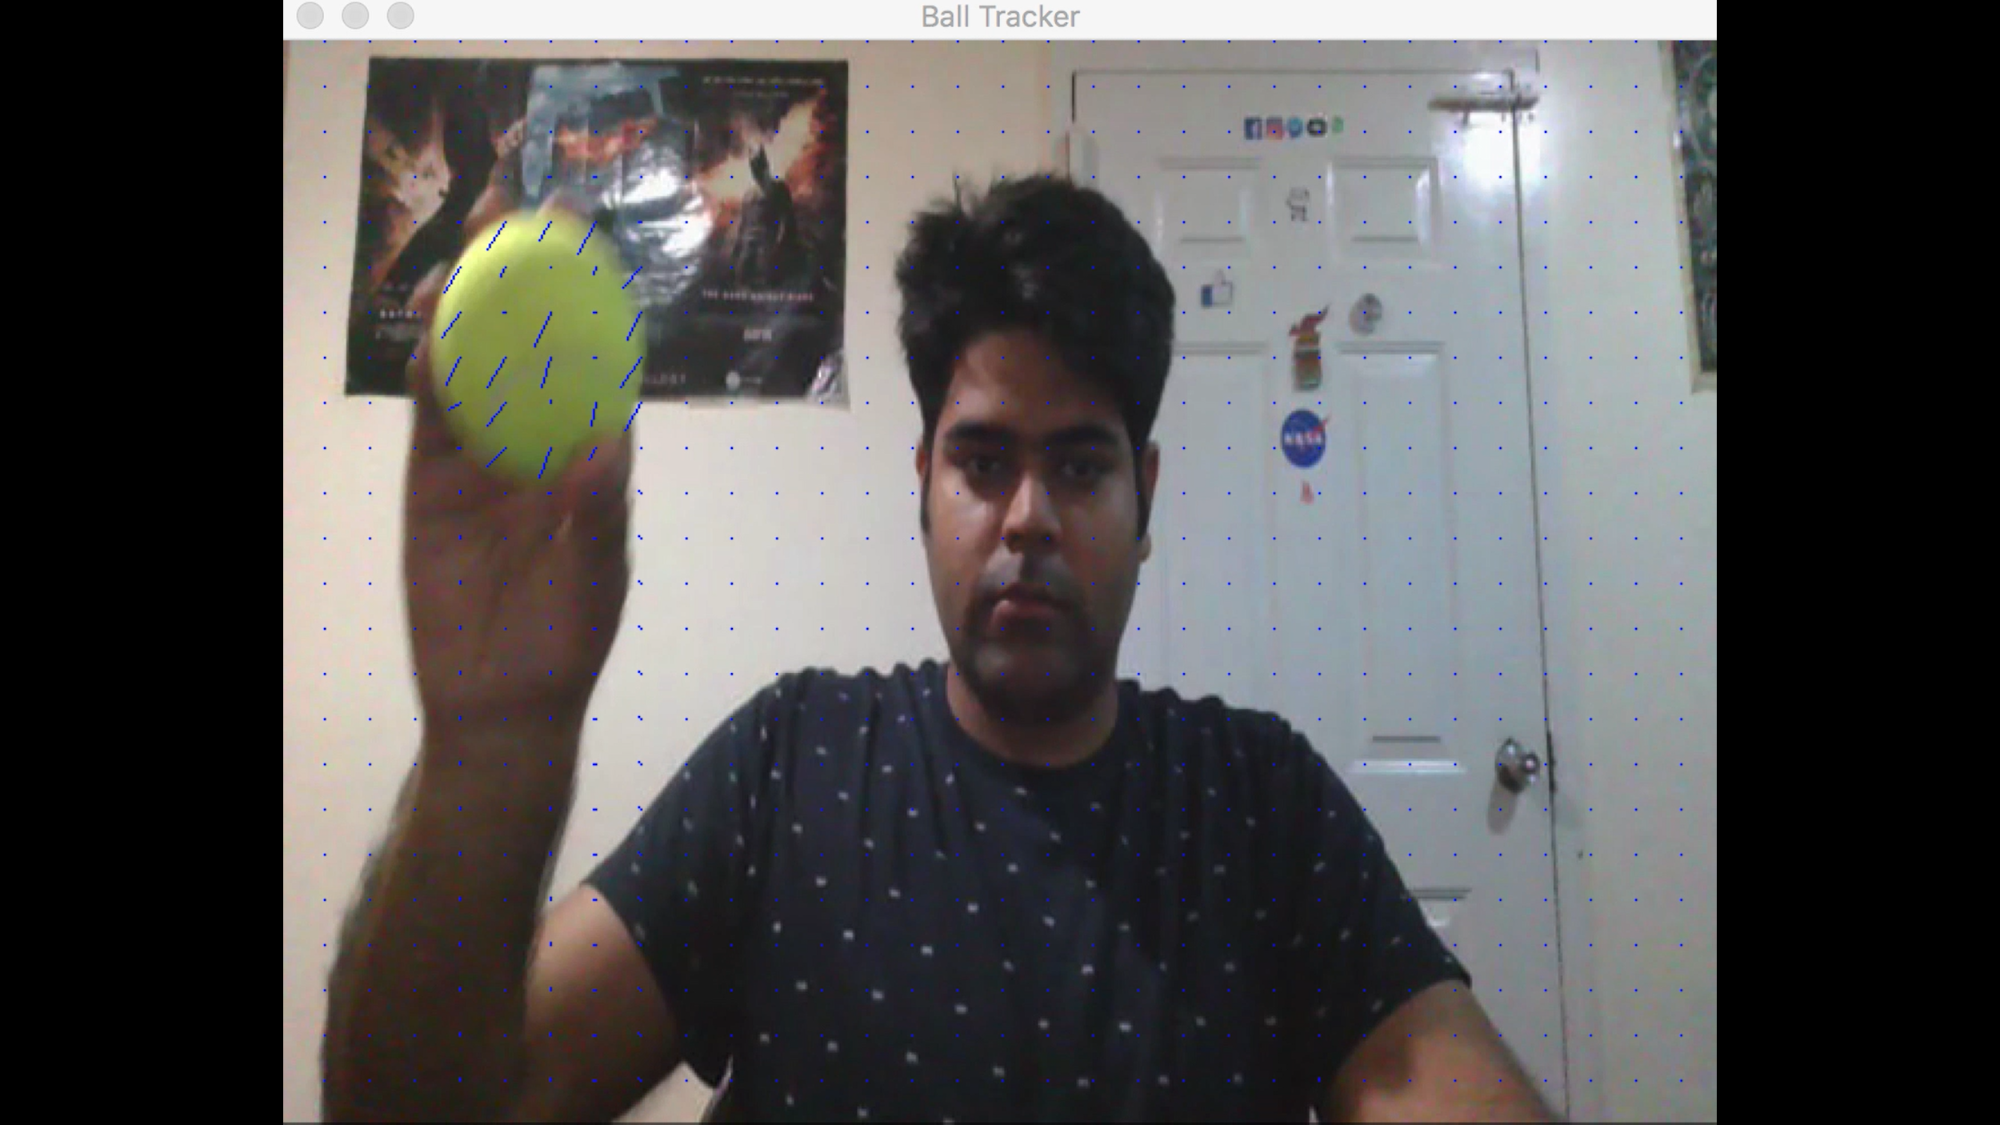

Fig 6. Optical Flow for green Ball

**Testing / Validation:**

As can be seen in the following results, the orange ball’s flow is not getting detected as we have masked the frame to detect only green ball.

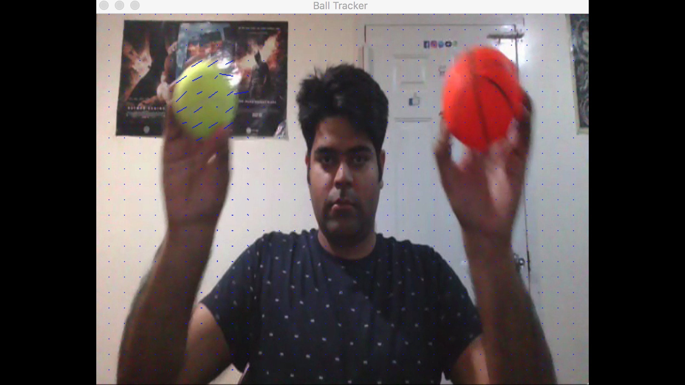 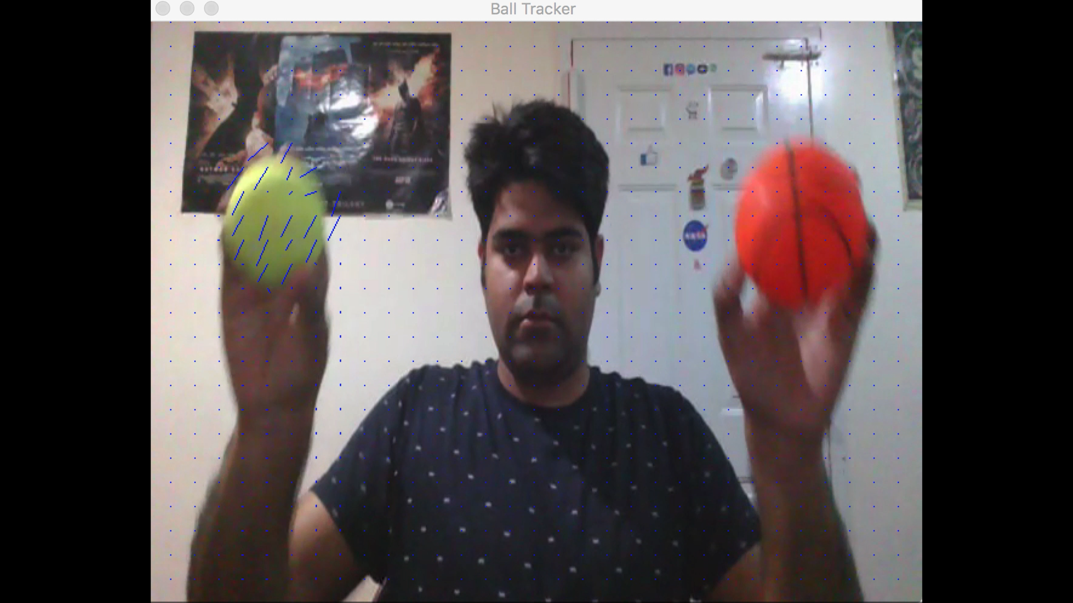

Fig 7. Only green ball’s flow is been detected

**Conclusion:**

We can conclude by saying that we can track the ball using both Hough Transform and Optical Flow algorithms. We can use this system in various real time activities including sports like baseball, soccer, cricket etc. We got satisfactory results from both the algorithms.

**Critical Discussion:**

1. Hough Transform implementation is very computational heavy - it is hard to implement it in real life situations.
2. Currently our Optical Flow implementation is unable to perform depth perception.

**Future Scope:**

1. We can more efficiently implement both our algorithms to make it more useful for real life.
2. Try to implement contour detection for tracking a ball
3. Implementing depth detection using optical flow to get more sophisticated results

**References:**

* Professor Guido Gerig’s class notes
* Wikipedia page for Lucas-Kanade Method: <https://en.wikipedia.org/wiki/Lucas%E2%80%93Kanade_method>
* <https://www.pyimagesearch.com/2014/08/04/opencv-python-color-detection/>
* Wikipedia page for Hough Transform: <https://en.wikipedia.org/wiki/Circle_Hough_Transform>

**Work Division:**

* Mayank Lamba
* Implementation of Optical flow.
* Implementation of HSV masks in Optical Flow/Hough Transform..
* Pre-processing(smoothing, edge/orientation map for Hough Transform
* Final presentation and report
* Vivek Bharti
* Implementation of Optical flow.
* Improving efficiency of HSV masks using erosion and dilation.
* Frame resizing for flow matrices and Hough transform
* Final presentation and report
* Anshul Sharma
* Hough Circle detection.
* Speed up Hough circle detection for real time video.
* Implementation of resizing window feature to speed up code.
* Final report